**Project Design Phase-I**

**Solution Architecture**

|  |  |
| --- | --- |
| Date | 19 September 2022 |
| Team ID | PNT2022TMID53187 |
| Project Name | Developing a Flight Delay Prediction Model using Machine Learning |
| Maximum Marks | 4 Marks |

**Solution Architecture:**

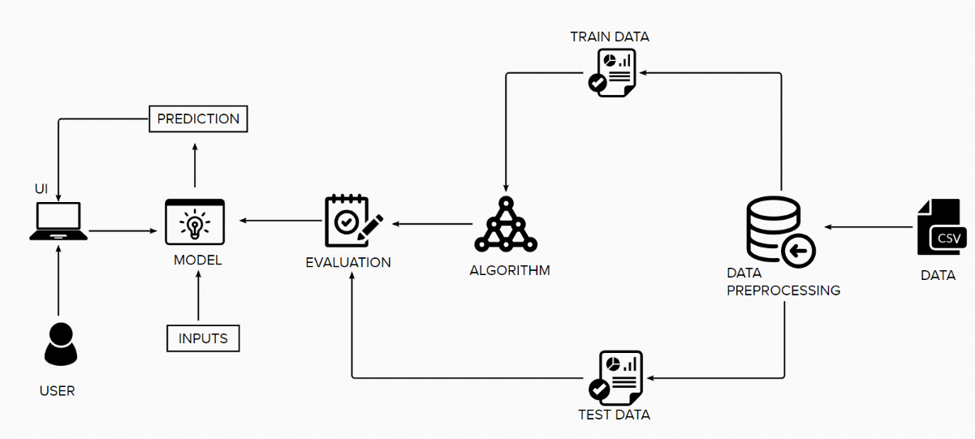

**Technologies needed for Flight Delay Prediction Model:**

Upon research we found that we need the following software technologies for systematic development and deployment of the project:

* Python
* Python Web Frame Works
* Python For Data Visualization
* Data Preprocessing Techniques
* Machine Learning
* IBM Cloud
* IBM Watson Studio
* Python-Flask